Carobot V3  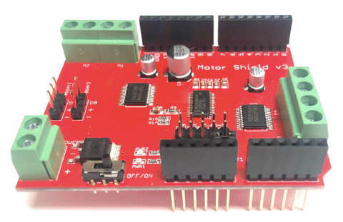 | Motor Shield | Issues:  Is connected to I2C( Need to jump cables)  Has an allcall address of 0x70, which conflicts with the multiplexer. | Documentation  https://learn.carobot.ca/guide/motor-shield-v3
TCA9548A qwiic mux  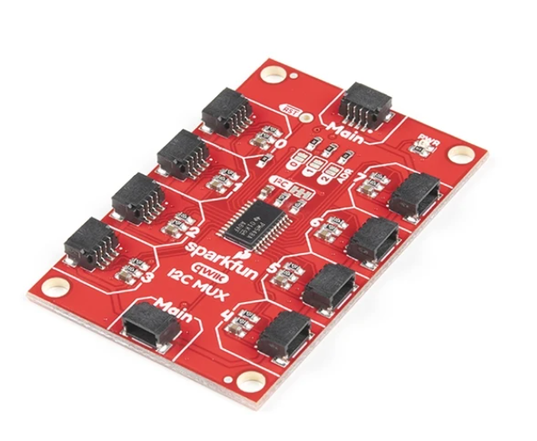 | I2C multiplexer | Address conflicts with Carobot.  Pins get easily deformed | https://cdn.sparkfun.com/assets/f/0/4/b/3/tca9548a.pdf
BNO055 absolute orientation sensor  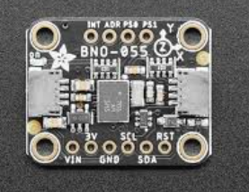 | IMU | The sensor has no reset: the heading is always global.  The sensor has a 360 degree wraparound, which is sensitive to fluctuations. | https://cdn-shop.adafruit.com/datasheets/BST_BNO055_DS000_12.pdf  code:https://adafruit.github.io/Adafruit_BNO055/html/class_adafruit___b_n_o055.html
VL53L0X TOF sensor  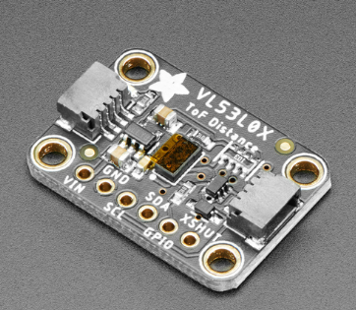 | TOF Lidar | The sensors I2C address is 0x29, which conflicts with TCS34725.  Can’t handle below 30mm of range | https://learn.adafruit.com/adafruit-vl53l0x-micro-lidar-distance-sensor-breakout/overview
TCS34725  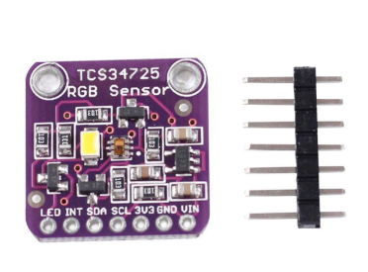 | Color sensor | Its unchangeable address conflicts with Vl53l0X.  Measurement takes 50ms | https://adafruit.github.io/Adafruit_TCS34725/html/class_adafruit___t_c_s34725.html
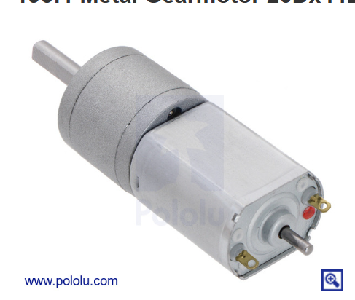  195:1 Metal Gearmotor 20Dx44L mm 12V CB with Extended Motor Shaft | Motor | Extended shaft for encoder | https://www.pololu.com/product/3493
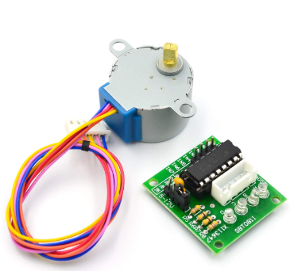 | Stepper motor | The motor itself is 5V, so you need a 5v buck. | https://lastminuteengineers.com/28byj48-stepper-motor-arduino-tutorial/
OpenMV H7 plus.  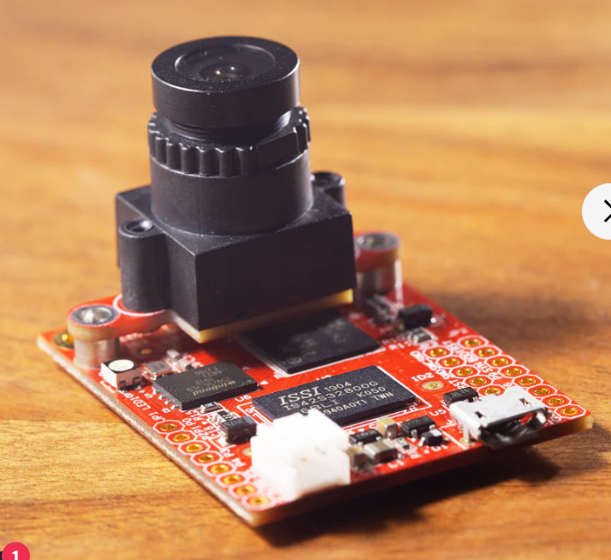 | Camera | Memory can leak from power brownouts without and SD card. | https://docs.openmv.io/library/omv.image.html
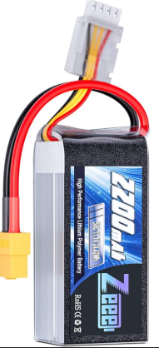 | Lipo battery | ALWAYS unplug the robot before charging.

Consolidated Competition Bill of Materials
Quantities below were imported from BoM for worlds.xlsx. Prices were checked on June 12, 2026 and exclude tax and shipping. Representative prices are clearly labeled where the exact model is still unknown.
Component / part number | Supplier / source | Status | Kit/custom-built | Required / existing / spare | Unit price (USD)
Processor/controller board (exact model TBD) | Supplier TBD; exact model required | Reused; inventory recorded | Kit/off-the-shelf | 0 / 2 / 1 | TBD - exact model required
Adafruit VL53L0X time-of-flight sensor, PID 3317 | Adafruit: https://www.adafruit.com/product/3317 | Reused | Kit/off-the-shelf | 7 / 14 / 1 | $14.95
Adafruit TCS34725 color sensor, PID 1334 | Adafruit; discontinued: https://www.adafruit.com/product/1334 | Reused | Kit/off-the-shelf | 1 / 2 / 0 | $7.95 listed; discontinued
Adafruit BNO055 orientation sensor, PID 2472 | Adafruit: https://www.adafruit.com/product/2472 | Reused | Kit/off-the-shelf | 1 / 2 / 0 | $34.95
Motor encoders (assumption: Pololu 20D encoder pair kit, item 3499) | Pololu; confirm model: https://www.pololu.com/product/3499 | Reused; installed quantity unknown | Kit/off-the-shelf | 2 packs / unknown / 1 pack | $9.95 per pair kit
OpenMV Cam H7 Plus, SKU OMV-CAM-H7-PLUS-V1 | OpenMV; sold out / production-run order only: https://openmv.io/products/openmv-cam-h7-plus | Reused | Kit/off-the-shelf | 2 / 4 / 0 | $135.00
Pololu extended-shaft gearmotor; spreadsheet says 150:1, linked item 3493 is 195:1 | Pololu; confirm ratio/model: https://www.pololu.com/product/3493 | Reused | Kit/off-the-shelf | 4 / 8 / 1 | $32.95 for linked 195:1 model
28BYJ-style 5 V geared stepper (representative: Adafruit PID 858) | Adafruit; out of stock; confirm model: https://www.adafruit.com/product/858 | Reused | Kit/off-the-shelf | 1 / 2 / 4 | $4.95 representative
LCD screen (model TBD) | Supplier TBD | Reused | Kit/off-the-shelf | 1 / 1 / 1 | TBD
LED strips (type/length TBD) | Supplier TBD | Reused | Kit/off-the-shelf | 3 / 3 / 0 | TBD
M4 suspension screws (specification TBD) | Supplier TBD | Reused | Kit/off-the-shelf | 1 set / 2 sets / 0 | TBD
Ball bearings (size/model TBD) | Supplier TBD | Reused | Kit/off-the-shelf | 2 / 4 / 5 | TBD
Motor brackets (model TBD) | Supplier TBD | Reused | Kit/off-the-shelf | 4 / 8 / 6 | TBD
Protoboard (representative: Adafruit half-size Perma-Proto, PID 1609) | Adafruit; confirm dimensions: https://www.adafruit.com/product/1609 | Reused | Kit/off-the-shelf | 1 / 2 / 1 | $4.50 representative
Qwiic cables (assumption: 100 mm JST-SH 4-pin, Adafruit PID 4210) | Adafruit; confirm lengths: https://www.adafruit.com/product/4210 | Reused | Kit/off-the-shelf | 10 / 18 / 0 | $0.95 each
Circuit breaker (rating/model TBD) | Supplier TBD | Reused | Kit/off-the-shelf | 1 / 1 / 3 | TBD
Wire clips (type/quantity TBD) | Supplier TBD | TBD | Kit/off-the-shelf | TBD / TBD / TBD | TBD
JST-PH cables (representative: Pololu 6-pin female-female 10 cm, item 5643) | Pololu; confirm pin count/length: https://www.pololu.com/category/361/6-pin-jst-ph-style-cables | Reused | Kit/off-the-shelf | 4 / 8 / 2 | $3.23 representative
Pololu D24V50F5 5 V regulator, item 2851 | Pololu: https://www.pololu.com/product/2851 | Reused | Kit/off-the-shelf | 1 / 1 / 0 confirmed | $29.95
CAROBOT Motor Shield V3, SKU 2337 | Canada Robotix: https://www.canadarobotix.com/products/2337 | Reused; quantity TBD | Kit/off-the-shelf | TBD / TBD / TBD | CAD $19.99; USD price TBD
SparkFun Qwiic Mux - 8 Channel (TCA9548A), BOB-16784 | SparkFun: https://www.sparkfun.com/sparkfun-qwiic-mux-breakout-8-channel-tca9548a.html | Reused; quantity TBD | Kit/off-the-shelf | TBD / TBD / TBD | $6.95
LiPo battery (specification TBD) | Supplier TBD | Reused; quantity/condition TBD | Kit/off-the-shelf | TBD / TBD / TBD | TBD
Robot mechanical structure and wiring assembly | Team designed and assembled | Reused; verify configuration | Custom-built | 1 assembly / TBD / TBD | Material costs TBD
Required follow-up before submission
Confirm exact models and physical quantities; resolve the spreadsheet's 150:1 gearmotor description against the linked 195:1 Pololu item; and price every remaining TBD entry before submission.

Pricing summary
Partial replacement subtotal: $631.07 USD. This includes only rows with known required quantities and traceable USD prices or explicitly stated representative assumptions. It excludes tax, shipping, the CAD-priced CAROBOT shield, unknown required quantities, and all remaining TBD items.
Prices and availability were checked June 12, 2026 and should be rechecked before ordering.

